Day 22
Task 1:
What do you mean by GOOD Code and BAD CODE?
Good Code
Good code in Java is characterized by the following qualities:
- Readability: Code is easy to understand, with clear and concise variable names, method names, and comments.
- Maintainability: Code is modular, flexible, and easy to modify without introducing bugs or affecting other parts of the system.
- Efficiency: Code is optimized for performance, with minimal unnecessary computations, memory usage, or database queries.
- Reusability: Code is designed to be reusable, with minimal dependencies and well-defined interfaces.
- Testability: Code is easy to test, with clear and concise unit tests that cover various scenarios.

Bad Code
Bad code in Java, on the other hand, shows the following characteristics:
- Complexity: Code is overly complex, with convoluted logic, nested conditionals, and unclear variable names.
- Rigidity: Code is inflexible, making it difficult to modify or extend without introducing bugs or affecting other parts of the system.
- Fragility: Code is prone to breaking when changes are made, due to tight coupling or unclear dependencies.
- Code Duplication: Code is duplicated in multiple places, making maintenance and updates more challenging.
- Lack of Comments: Code lacks clear and concise comments, making it difficult for others to understand the logic and intent.
2. What do you understand by databinding?
Data binding in Java refers to the process of linking UI components to data sources, enabling automatic updates when data changes. It simplifies code, improves responsiveness, and reduces boilerplate code.

Types
- One-way data binding: Data flows from source to UI.
- Two-way data binding: Data flows between source and UI.

Benefits
- Reduced code complexity
- Improved responsiveness
- Simplified maintenance
3. What do you know about continuous development?
Continuous Development (CD) in Java involves practices and tools that enable rapid and reliable delivery of software applications.
- Continuous Integration (CI): Tools like Jenkins, Travis CI, or CircleCI integrate code changes into a central repository, running automated tests and builds.
- Automated Testing: JUnit, TestNG, and other testing frameworks ensure code quality and functionality.
- Continuous Deployment (CD): Tools like Jenkins, GitLab CI/CD, or CircleCI automate deployment to production or staging environments.
- Monitoring and Feedback: Tools like Prometheus, Grafana, or ELK Stack track application performance and provide insights for improvement.
Java-Specific Tools
- Maven or Gradle: Build automation tools that manage dependencies and simplify the build process.
- Spring Boot: A popular framework for building microservices and web applications, with built-in support for CD.
- Docker: Containerization technology that enables easy deployment and scaling of Java applications.
4. What are the conditions for polymorphism?
Polymorphism in Java is achieved through method overriding or method overloading. Here are the conditions for polymorphism:

Method Overriding
- Inheritance: The subclass must inherit from the superclass.
- Method Signature: The method in the subclass must have the same name, return type, and parameter list as the method in the superclass.
- Method Body: The method in the subclass can have a different implementation than the method in the superclass.

Method Overloading
- Same Method Name: Multiple methods with the same name can be defined.
- Different Parameter List: The methods must have different parameter lists, either in terms of the number of parameters or the types of parameters.
- Return Type: The return type can be the same or different.
5. What is, why is it used , where is it used.. TDD and BDD approach..
TDD (Test-Driven Development)
- What: TDD is a software development process that relies on writing automated tests before writing the actual code.
- Why: TDD ensures that the Java code is testable, meets requirements, and reduces bugs.
- Where: TDD is widely used in Java development, especially in Agile and Extreme Programming (XP) methodologies.
BDD (Behavior-Driven Development)
- What: BDD is an extension of TDD that focuses on defining the behavior of the Java system through natural language conversations.
- Why: BDD ensures that the Java system meets the required behavior and functionality.
- Where: BDD is used in Java development, especially in collaborative environments.
Java-Specific Tools
- TDD: JUnit, TestNG
- BDD: Cucumber-JVM, JBehave
Benefits
- Improved quality: Both TDD and BDD ensure that the Java system meets requirements and is testable.
- Reduced bugs: Writing tests before code helps catch bugs early.
- Improved collaboration: BDD promotes collaboration between stakeholders

Task 6:
List down the Manual and automated testing tools:
Manual Testing Tools
- BrowserStack Live and App Live
- TestLink
- Jira
- Bugzilla
- Citrus
- Testsigma
- Snagit
- Loom

Automated Testing Tools
- Selenium
- Appium
- TestComplete
- LambdaTest
- Testim
- Tricentis Tosca
- Apache JMeter
- Cucumber
- JUnit
- NUnit
- PyUnit
- TestNG

Task 7:
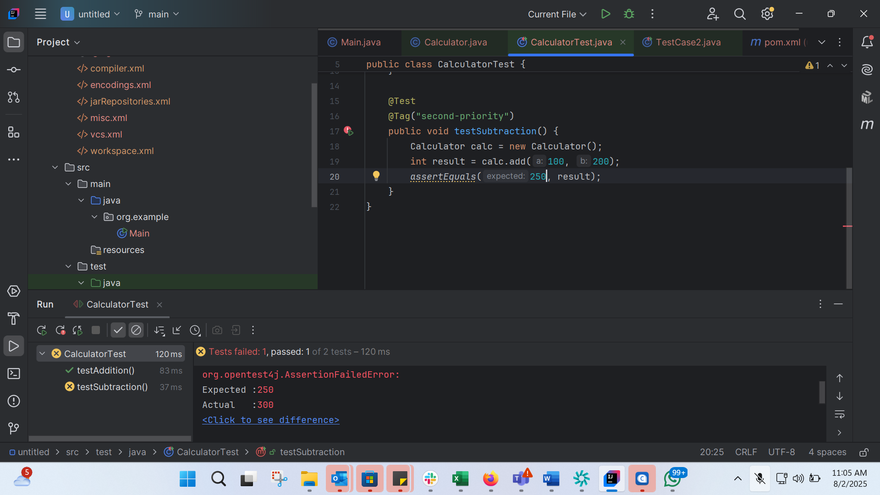
import org.junit.jupiter.api.Tag;
import org.junit.jupiter.api.Test;
import static org.junit.jupiter.api.Assertions.assertEquals;
public class CalculatorTest {
@Test
@Tag("first-priority")
public void testAddition() {
Calculator calc = new Calculator();
int result = calc.add(2, 3);
assertEquals(5, result);
}
@Test
@Tag("second-priority")
public void testSubtraction() {
Calculator calc = new Calculator();
int result = calc.add(100, 200);
assertEquals(250, result);
}
}

public class Calculator {
public int add(int a,int b){
return a+b;
}
}

